**CS – 590.21 Analysis and Modeling of Brain Networks**[**Department of Computer Science**](http://www.csd.uoc.gr/)**University of Crete**

**Plot of a Network and Degree of Connectivity – ReadMe file**

This analysis introduces the script main_graph that takes as input the following datasets:

1. the biological data of an animal that contains information about the number of neurons, the type (e.g., interneuron, astrocyte or pyramidal) and the coordinates of each neuron
2. the representation of a network which is an m x 2 array (m: the number of edges in this network). Each row represents a connection between the neuron with the id of the first column and the neuron with id of the second column.

Considering the connections of the network and the coordinates of the neurons this script draws the network. Following main_graph estimates the degree of connectivity (DoC) of each neuron and produces the CDF plot and statistics of the DoC.

In order to produce these plots and statistics the following functions are used in the main_graph script:

* plot_graph (representation of the network)
* DoC (estimation of the degree of connectivity)

After downloading this folder, start form the main_graph script, on the command window of the Matlab run the following command: *main_graph* 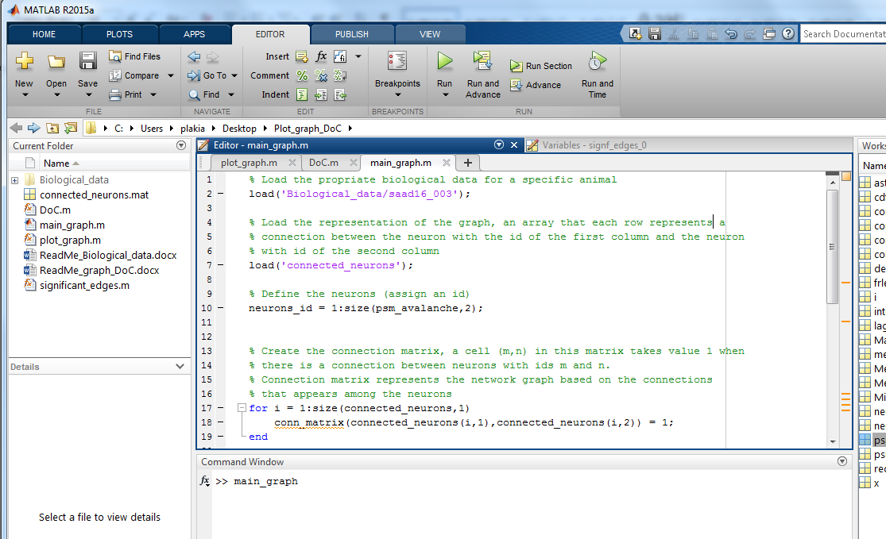

This command will produce all the plots and statistics that are described above.